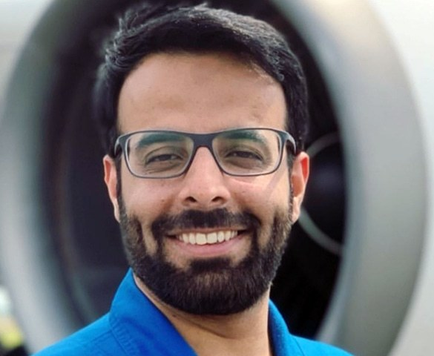
Dr Yarjan Abdul Samad, PhD is a Senior Research Scientist and a Senior Teaching Fellow at The University of Cambridge. His research work is based on Space based technologies. He was among the team of scientists on European Space Agency (ESA)’s Zero Gravity flight who were the first to test Graphene, a modern day marvel material, in Zero Gravity. Besides doing scientific experiments in Zero Gravity flights he also performs experiments in Sounding Rockets. Dr Abdul Samad and his team are slated to take their experiments to the International Space Station in collaboration with the Microgravity Research Center in Brussels, ESA and other European partner institutions and private sector organizations. He is also a member of the Mohammad Bin Rashed Space Center’s Moon Mission launching in 2022. His invention on cooling devices in Space has been covered by international media including but not limited to Reuters, Techradar, CNET, InnovaSpace etc. He has won several awards for his research work such as The Innovator Of The Year by the technology development company, The Outstanding Research Reviewer of the year 2017 by the Royal Society of Chemistry UK, YPS Young Leader Award 2020, Nano Today Best Scientific Presentation and many other Best Scientific Talks awards at international scientific conferences. In addition to research he teaches on graphene technology at the University of Cambridge and supervises numerous masters and PhD students. He also lectures at several other international academic institutions (e.g. Chalmers Institute of Technology, University of Manchester, Lincoln University). He has authored a book and about 60 internationally refereed scientific journal articles, conference proceedings and presentations. He is a guest editor of a scientific journal called Sensors. Prior to moving abroad he obtained his bachelors degree in engineering from Ghulam Ishaq Khan Institute (GIKI) in Pakistan. He holds 4 patent applications. He graduated from GIKI with two gold medals (one for best academic performance and another for best overall performance). Dr Yarjan Abdul Samad belongs to Buleda, a village near Turbat in Baluchistan, Pakistan and has acquired his early education from his native village.

